Interface Description

Interactive simulator for a game (Planetside 2)

- simulate physics used in-game to visually display in 2-D to users

- include the effects of gravity (bullet-drop) and travel time (bullet velocity)

of objects (bullet rounds) used in a game

- a movable line to indicate where the person is aiming the object

- allow for users to either input angle value or click on the line and move it

- able to dynamically update the projected path of an object

- include a database of variety objects (vehicle, aircraft and infantry based weaponry)

- each objects include different values of velocity

- each objects may include different added on objects to modify its velocity

Interface Requirements

Users

- able to see and pick from a list an object they want to use

- will include filters to allow them to quickly found what they need

- able to change the angle, distance and time

- angle; by moving a crosshair to represent where they aim

- distance; the size of the graph width wise

- time; time given for the object to fly along its trajectory

- allow to toggle between two different modes

- one dynamically updates the line representing the objects' trajectory instantaneous

- one will slowly draw to represent an object's trajectory

- allow for comparison view between two objects

User-Centered Design Choices

Visibility of system status

- app will be able to dynamically redrawn to reflect the user action

User control and freedom

- will contain a history of points where the crosshair is moved by the user and allow them to cycle through

Aesthetic and minimalist design

- Will be using simplified drawings to represent complex graphics

Error prevention

- Will be checking user input to see if they are the correct data type needed

Help and documentation

- may include a button that toggles an overlay to display tooltips for the available features

Recognition rather than recall

* - A list of all previous target positions will be clearly visible, plus all calculations will be mapped on to the graph.

Risks and Issues

* Computer’s crashing and losing all the data for the application
* Procrastination and neglection of the project could lead to missing deadlines
* jQuery and Javascript needed for graphic component
* Multi-Browser compatibility
* Scope of project may be too small
* Physics equations may not be properly implemented giving unpredictable results.
* Graph display may be difficult to implement
* PHP calls to database may not be OS portable, double check that they are not Windows specific.
* Loss of internet connection at BCIT may slow down progress

Early Prototype

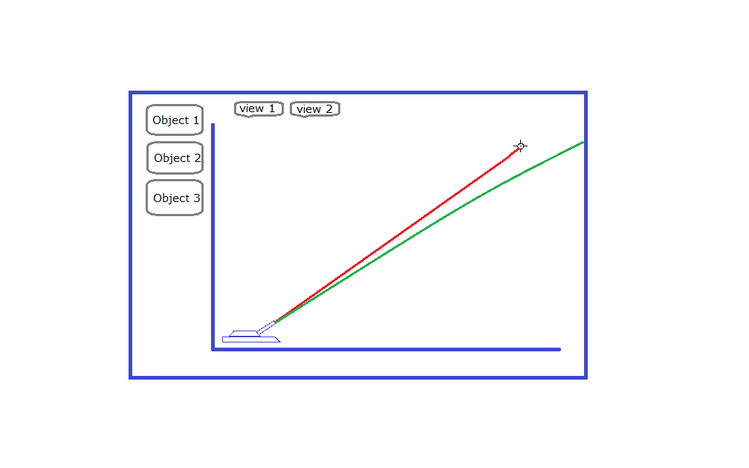

Task Analysis

User Task Analysis

* I want to be able to select an object
* I want to be able to change between a graph view and an animation view
* I want to be able to compare 2+ different objects
* I want to be able to change the line of aim
* I want to be able to manually change the time of flight or distance that the projectile travels
* I want all my previous calculations to be saved in a list where I can view them again later